Research Integrity through Better Data Management
July 2025

Foreword
Transparency and integrity are crucial to academic research. A fundamental means to achieve research transparency and integrity is through adopting best practices in management, sharing and analysis of data. Since 2019, CHIBE has engaged with affiliated faculty, research staff, data analysts and other experts in developing best practices in data analytics management to promote efficiency and quality in research, while preventing data manipulation and minimizing suboptimal data handling. Promoting research transparency and integrity through data best practices ensures that data is collected, stored, coded and shared in a way that is transparent, accessible and secure. Our approach includes developing clear protocols for data collection and storage, ensuring study data and meta-data are properly documented and labeled, and data, codes and analysis plan follow FAIR standards (findability, accessibility, interoperability and reusability). We minimize the risk of data manipulation through promoting access to the Center’s standing pool of analysts who are trained and familiar with data management protocols but not directly supervised by lead researchers. Other arrangements include requirement of archiving raw data, logging study decisions, and delineating the roles in research to prevent one person from assuming all roles. We acknowledge that not all researchers have the funding resources to hire analysts and may do analyses themselves for that reason.
Better data practices are possible when research leadership is fully committed. Although current best practice guidelines and training mostly focus on our analysts, other research staff play important roles as well. Principal Investigators and research leads are critical enablers (e.g., allocating time and resources that allow staff to complete data management related tasks). We propose that project-level management be led by the lead analyst and project manager under the direct oversight of the Principal Investigator, while the CHIBE Sr. Data Manager offers cross-project oversight, tactical support, training and guidance throughout the lifecycle of research.
See project lifecycle graphic below.
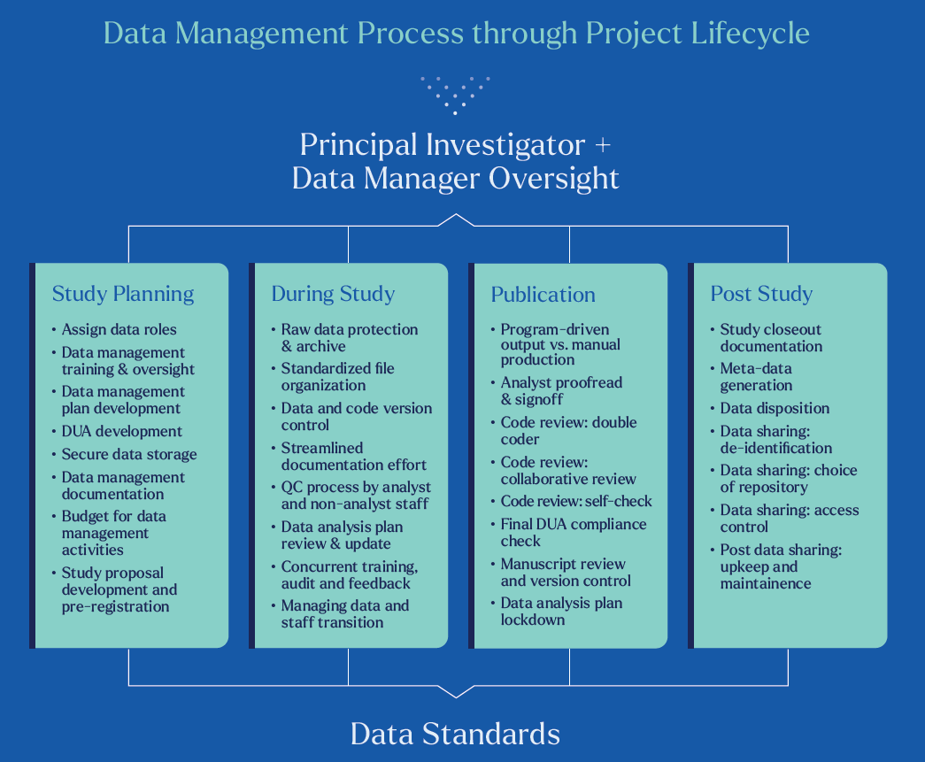
* Selected resources throughout this advisory, including project-specific examples, are currently stored at PENN+BOX with controlled access. Other interested readers are asked to email Jingsan@upenn.edu to request access and indicate intended use of this resource. Users are asked not to further distribute any documents without seeking approval first.
** Please contact Jingsan@upenn.edu for feedback, suggestions, questions, recommendations or requesting additional resources or guidance
Overview of Data Best Practices throughout Project Life Span
- Before study begins
Data roles and data management planning
  - It is important to specify data owner, custodian and data users for each project, with access privileges, responsibilities and liabilities for each party clearly outlined.
  - CHIBE’s acting Sr. Data Manager is available for reviewing and advising on best data practices, and initiating training as appropriate
  - Research teams should carefully plan, discuss and review data management process before study starts and throughout research lifecycle. Project teams are encouraged to review and use the Data Management Checklist prepared by CHIBE, and a Data Management Plan is strongly recommended before study begins.
  - Research team members should be familiar with the governing Data Use Agreements (DUA) and understand related data responsibilities. CHIBE developed a DUA Tracking Report that can be used as a project management tool to track active DUAs and data information to ensure compliance.
  - Set up secure data storage and transportation that meet HIPAA rules and other institutional policies and privacy regulation. We strongly recommend research data with PHI to be hosted at PENN Medicine’s Health Services Research Data Center (HSRDC) to minimize risk of any data breaches
  - Study teams running trials should define "ground truth" data sources for key outcomes both before and during the study, which will ease end of study data reporting and reconciliation. QC process/reviewing of primary data collection needs to be planned early
  - Plan robust version control so data and programming files can be tracked and restored if needed
  - Assess training needs especially when a project involves students, trainees or junior staff or analyst
Proposal development and pre-registration
  - Each study should be covered by an initial research proposal by the lead investigator with working hypotheses clearly stated, and research data and analytical methods clearly identified.
  - Any clinical trial funded by a federal agency, such as the NIH, needs to be pre-registered through ClinicalTrials.gov
  - In prospective research such as RCTs, material deviations from original study plan should be carefully justified, documented and disclosed
  - Widely used by clinical trials at CHIBE and other research institutions, Way to Health (W2H) is a web-based platform that provides technology infrastructure for sustainable behavior change interventions. W2H is working on requiring all studies on its platform to submit clinicaltrials.org registration information before they can enroll any participants. Furthermore, source data stored at W2H cannot be edited, and program logs and other study records are permanently stored.
  - Although there are clear standards for reporting and registration of prospective research such as RCTs, expectations for registering retrospective research are less consistent and subject to debate. While much attention has been paid to data integrity issues with experiments, problematic analytic techniques such as p-hacking can be an issue either with experimental or non-experimental data.
  - For retrospective study (including exploratory study), we recommend a preliminary proposal be established and documented to prespecify the hypothesis, primary outcome, and mode of analysis before research data is received or extensively reviewed. It needs to be accompanied by a study decision log used to chronologically document changes of study methods with justifications, made available to reviewers and readers if requested.
- Retrospective studies or observational studies can be registered externally through clinicaltrials.gov or other places including As-Predicted by CredibilityLab. Other internal registration options can also be explored.

- During study

Data management

  - CHIBE discourages faculty investigators from assuming all data-related roles to reduce risk as well as perceived risk of data manipulation.
  - Source data should be stored securely in a protected space (e.g. HSRDC/Origdata) with restricted access and separate from the main project folder. Source data should not be modified without authorization and be free from tampering. Any file modification should be logged so changes will be trackable. We strongly recommend data be stored in a host system with robust version control and file recovery capabilities.
  - Standardize file organization. CHIBE has proposed using a Standard File Organization that is consistent with how research data are generally constructed and analyzed by analysts. Standard folder structure should include /documentation, /Build (building analytical datasets), /Analysis (main analysis using analytical data), and /Project Closure (final version of research production and document lockdown)
  - Create a protected, common data set for frequently used or shared data to avoid duplication or incidental change to individual copies
  - CHIBE recommends using Data Transmittal Form to log and track data sharing and uploading activities
  - Protect data security through de-identification or use of limited data set whenever possible
  - Project staff and analysts should actively discuss and agree upon documentation processes (including choice of storage and sharing arrangement) with clearly specified role-specific responsibilities to make data management a more streamlined process. Avoid relying on emails as project management tool.
  - QC Process- primary data collection and review: project staff should - routinely review data missingness, outliers, consistency in naming conventions, check assumptions (by a staff supervisor or project lead), and establish adjudication rules . Understanding downstream impact of data collection, processing and quality review is critical.
  - QC Process-secondary data collection and review: project staff and analysts should develop a detailed, comprehensive data dictionary and variable code book to guide the process of secondary data pull from EMR systems. Outliers and missingness need to be routinely reviewed and adjudicated. Joint data planning and review sessions between project staff and analysts are important to ensure high quality in secondary data collection. Secondary data should always be version controlled and accompanied by a data dictionary when shared. Consistency between sequential data copies should be checked with each data update.
  - We call for better communication between project management staff and analysts to better appreciate distinct responsibilities, clarify expectations and offer mutual support essential for a streamlined data management process and higher quality data analysis.
Data analysis
  - Each research project should include a detailed Data Analysis Plan (DAP). DAP is a live document used to capture key data decisions, hypotheses, and analytical process carried out by the project analyst. DAP should be prepared based on the initial research proposal, or Statistical Analysis Plan (SAP) if available, and reflect a pre-submitted analysis plan. Deviation or revisions should be clearly documented to reflect any updates as the project progresses, but the principle of pre-registration of all primary outcomes and the analysis plan should be adhered to unless sufficiently justified. CHIBE has provided a checklist for robust DAPs with examples
  - DAP should contain sufficient details in data processing and analytical methods so readers will be able to replicate your work
  - Data and statistical reports prepared by analysts are an important tool to facilitate internal data analytics discussion and need to be consistently documented. Data reports should be version controlled (e.g., timestamped), structured to reflect the iterative nature of the investigation process (e.g., current tasks/issues, actions taken/investigation performed, next step), and kept updated by the analysts
  - Analysts should always check data quality, identify abnormalities and inconsistences, report missing data and outliers before performing statistical analysis
  - Analysts are encouraged to use tools such as Markdown or GitHub to create dynamic documentation during programming
  - CHIBE has provided a Training and Resource Deck for Analysts to promote skill development in claims data analysis, randomized clinical trials, and methods commonly used in natural experiments or quasi-experiments
  - Project transition needs to be carefully planned with the stakeholders clearly identified with an oversight structure, and the process clearly outlined to minimize project interruption and maximize retention of project knowledge. CHIBE offers a checklist for data project transition to facilitate this process

- Manuscript preparation and publication

  - Project teams should actively discuss methods for code review. Depending on budget and other considerations, there are three options: 1. Analyst self-review; 2. Collaborative code review; and 3. Double/parallel coding.
  - Double/parallel coders is the most robust way of ensuring the analyses are done properly and that any mistakes are detected before submitting for publication. The Health Economics Data Analyst Pool (HEDAP) at LDI provides additional analyst bandwidth to support replication work if requested and if funding allows.
  - When double coding is unlikely or impractical, the next best option would be collaborative code review in which an independent analyst works closely with the primary project analyst to critically review line-level code and verify coding logic and code performance. In all scenarios, we strongly encourage study PIs to allocate sufficient time throughout the study for analysts to perform frequent self-check.
  - Final research manuscript should be reviewed and proofread by the lead analyst with particular attention to the description of data, data processing and statistical modeling details. Data findings and reports need to be doubled checked for mistakes and misrepresentation. Manuscript should not be submitted without being reviewed by the lead analyst.
  - Certain stipulations in DUAs or contractual agreements limit what data can be reported in publication, and whether the manuscript needs to go through additional review process. Investigators need to understand such requirements and carefully consider these agreements and verify compliance.
- Post study
Project closeout
  - Formal closeout is required for each completed project or publication. Project PI should lay out expectations for study closeout process and discuss with analysts and other research staff about timeframe, budgeting and staffing needs
  - At the end of the study, the lead analyst will be asked to produce a project closeout document
  - The closeout memo should include: 1.) a data report that describes raw and derived data constructed during the study and 2.) a programming report that lists all statistical programs by running order during the data building and analysis phase. CHIBE has provided a template for project closeout memo with examples.
  - All final study data and supporting documents, including closeout memo, DAP and statistical report, need to be locked down and stored in a designated lockdown folder within project directory
  - Plan for data disposition when data use agreement expires. CHIBE has prepared a Data Disposition Log to document data disposition events along with information such as data location, destruction methods and paper trail
Data sharing
  - NIH, among other funding agencies, recently raised standards for scientific data sharing. Data sharing plans and methods should be reported during grant applications, according to the updated NIH policy. CHIBE performed a review of the updated NIH Data Management and Sharing Policy to help researchers better plan for these changes
  - Researchers are encouraged to maximize data sharing through well-established public data repositories, such as Dataverse, ICPSR, or OSF
  - Data sharing is not limited to research data. Meta-data, including code, data dictionary and supporting study materials, should accompany the shared scientific data to ensure transparency and replicability
  - To better plan for data sharing, some funding agencies such as the NIH require a formal Data Management and Sharing Plan (DMSP). Researchers can use the template for preparing NIH DMSP that CHIBE prepared for considerations such as what, when and how scientific data will be shared
  - In principle, data needs to be de-identified before sharing. CHIBE offers a de-identification checklist to help researchers determine the best de-identification strategies based on the safe-harbor method, as well as methods to de-identify dates and zip codes.
  - Researchers are encouraged to review the recommended list of free repository services that CHIBE curated. They are considered well-funded, feature-rich, with a broad and deep user base.
  - Shared data should have controlled access through a DUA. This helps to prevent access or use of data for unintended purposes which may also increase re-identification risk.

5. Data standards
CHIBE engages in broad behavioral intervention research, and there is substantial opportunity to enrich learning across projects. By building consensus on standards and common tools for data collection, measurement, analysis and reporting, there is greater opportunity for pooling data and earning across studies. Importantly, data standards reduce the chance of data manipulation, protect against unnecessary variations in data collection, analysis, reporting, and interpretation, leading to better transparency and comparability across studies.
  - Data format, labeling and generation of meta-data such as code book, case report forms, surveys, EHR queries and other data process should be as standardized as possible to maximize interoperability across projects
  - Standardize variable definition, naming and coding convention. If standardized instruments already exist, their definition, version and references need to be documented and reported. A study instrument codebook should be made available for reviewers or readers.
  - Study teams are encouraged to prepare standardized progress reports (i.e., milestone report) to minimize variation and misunderstanding. We expect all RCT studies to follow the Consolidated Standards of Reporting Trials (CONSORT) 2010 statement and the 2022 extension, including reporting on required checklist items.
  - For RCT studies, research teams need to provide clear definitions in reporting research discontinuation and other mechanisms leading to missing primary or secondary endpoints, including withdrawal of consent, study termination (e.g., change in eligibility or safety concerns), and other loss to follow-up (LTFU) listed with reasons. Deviations from Intention-to-Treat (ITT) need to be clearly stated and justified.
  - Statistical methods such as multiple imputation or other methods for handling missing data need to be clearly stated.
  - Reporting characteristics of study participants in Table 1 is greatly facilitated by adopting standardized measures. Teams are encouraged to apply the standardized coding scheme to report enrollee characteristics, so definition, classification and interpretation of variables will be consistent across studies. Although Table 1 column structure will be influenced by specific study design, general guidelines will be shared in regulating how missing data should be described and reported, and whether statistical test of Table 1 variables is appropriate.
Synopsis
Research transparency is possible when data management and analytical process are made transparent, and results can be replicated through data sharing. Data management should not be treated as an activity to facilitate research, but an essential component of high quality research that can withstand scrutiny. Although we hope all projects can meet recommendations outlined in this advisory, challenges such as budgetary constraints and contractual obligations may prevent ability to fully follow these recommended best practices. However, we encourage researchers to adopt these principles to the extent possible, through careful planning and review, within an oversight structure that focuses on accountability.
As evident in the Data Management processes outlined above, adherence to the best practices offers an essential tool for deterring dishonest research conduct and preventing honest mistakes in analysis, but the recommended approaches are effective only if all research team members adhere to these guidelines, and accountability is clearly assigned and frequently reviewed within an effective oversight structure. There should be built-in checks and balances.
Data management offers an effective tool in combating research misconduct, but more comprehensive approach is needed for creating and sustaining a research culture that fosters integrity and encourages adherence to best practices. The National Academies’ report on Fostering Integrity in Research recommended steps that individual scientists, research institutions, research sponsors, journal publishers and professional societies should take to meet these challenges and better protect integrity in research. Government agencies such as the NIH have adopted a higher standard to promote the sharing of scientific data as part of its grant review. These resources and recommendations will be routinely reviewed and communicated with our researchers and research staff, including through CHIBE’s website.

